John McFarlane, Chairman, TheCityUK, addressed TheCityUK Annual Conference in London this morning:’(30.06.16)
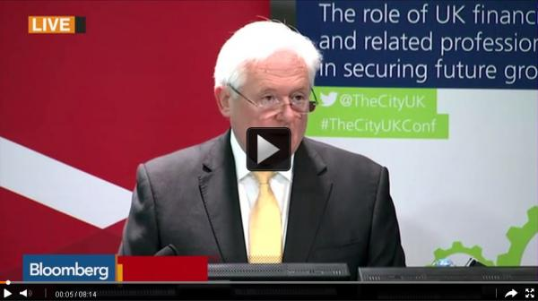
Thank you Jonathan and a special thanks to Nomura for hosting us today. We are enormously grateful to you for letting us use this beautiful building.
And I must say thank you to all of our speakers who will share their insights with us, not least Harriett Baldwin, Economic Secretary to the Treasury who has taken time in a very busy period to be here with us.
Well, what a difference a rainy day makes! We went to bed on Thursday being assured by the markets that by the morning it would be business as usual, but woke to find that the UK suddenly saw its future outside of Europe.
Make no bones about it, this has been a serious geopolitical and economic shock that requires a coordinated response. We now must build a new international model for the UK, naturally looking globally, but nevertheless retaining a strategic, but possibly different, partnership with the EU.
There remains a great deal of political and economic uncertainty and we need things to settle down and find a new equilibrium. For business, this is an exogenous shock, not self-inflicted, and raising uncertainty, the enemy of business, and of growth and return.
At this time we know neither the direction, nor the shape of things to come. We don’t know if exit is inevitable, nor the shape of an exit if it occurs. In the event of the former, relations with the EU will need to be repaired. In the event of the latter, a new paradigm needs to emerge. We can only hope that whatever transpires, is in the best interests of the country and our sector.
What we can be certain of is this is a time for leadership and for cool heads to prevail. Markets tend to overreact, and there is enough evidence that this is true in politics. Things eventually do settle and recover, but rarely return to their previous state.
But, in approaching the period ahead, while it is important to be ambitious, we must also be realistic. The genie is out of the bottle, and things may not be the same as before in our relationship with the EU. Given such a shock to the system, of course some things will change.
Page Break
In formulating a response to this situation, clarity is needed on what outcomes we want from the upcoming EU negotiations. While not exhaustive, some variant of the following are likely:
Access to the single market and to the UK
Some restriction on the free movement of people
Ability to employ talented workers from Europe and the rest of the world
Priority for financial and professional services
Following the past few days, no one can be in any doubt about the discontinuity that this issue has caused. Sterling has fallen, financial markets have been severely destabilised, and this has reverberated well beyond our shores.
At the same time, it is now even more likely that interest rates will be lower and for longer, reflecting future economic activity.
As a result of increased uncertainty and potential downward economic slope, the UK credit rating has been downgraded, together with 52 sub-sovereign UK entities. In turn, the rating of 12 banks, leading building societies, as well as some life insurers, have been put on negative outlook by Moody’s.
We now have a self-inflicted wound. Following the shock result, politics are now in disarray. The issue of independence of Scotland has also reared its head.
This is a political crisis that has the potential to create an economic one. Unlike the previous crisis, in this instance, the City does not bear the accountability. We have experienced an exogenous shock, and have acquitted ourselves admirably.
While it is perfectly understandable that it will take time for the country to find its feet, we do urgently need stable, effective and inspirational political leadership to steer the way forward.
Unfortunately it is far from certain what we might be able to secure in our discussions with the EU. It is nevertheless important for us to understand what options exist and to plan prudently for all contingencies.
Fortunately, we do have a great deal going for us. The UK is, with Germany, the largest European economy and recently has outperformed most developed countries. As such, it is a highly desirable place to do business.
Access to the UK market will be in demand and highly prized, particularly as the EU has a trade surplus with the UK. As such BMW, Renault and Airbus will wish to continue to export their products to the UK tariff free. Europe is certain to be our main trading partner for a long time to come.
The UK , and London in particular, is the leading financial centre globally, and is Europe’s financial centre. Europe’s capital markets are in not in Frankfurt, Paris, or Dublin, they are in London. This capability, together with related professional services, is a genuine competitive advantage that has been built over centuries, and is incredibly difficult to replicate or displace.
Foreign firms have an enormous presence in the UK to serve the UK market, but also as the preferred location for their European headquarters. English is, and will remain, the language of business.
Europe as a whole relies heavily on the UK for military and physical security, and in my mind, this is a strong card for us to play in discussions.
TheCityUK and our members can play a pivotal role in the period ahead. After all we are the largest segment, with 2.2 million employees across the UK. Ourselves, with McKinsey, are currently producing a strategic paper on the attractiveness of the UK Financial and Related Professional Services sector that we will publish soon.
We will offer clear recommendations about how we should set about the task of reinforcing the UK’s competitive advantage and advance our way in this new world. This naturally includes focusing on preserving our current position, particularly London’s role as the time zone’s financial centre.
Government, regulators and business are all in this together and need a way to develop and advance our common interests. In achieving this, we need to learn to promote ourselves more effectively. I’ve had the fortune to live recently in Asia and Australia. We can learn a great deal from the investment, energy and enthusiasm they put into developing commercial success.
Inevitably though, the UK will need to think more globally, looking to the wider world for our trade and investment opportunities. This is not new to us. The UK has always been a trading nation, with strong historical links to the Americas, the Commonwealth, and emerging markets.
At the same time, we need equally to think Europe, preserving and advancing to the extent possible, our shared economic interest.
A strong UK strengthens the world and advantages Europe, just as a strong Europe and international environment strengthens us. At its foundation is economic and political partnership. I’m therefore delighted that we have one of our leading political colleagues here with us to develop this theme further.
I know you will all share my gratitude that Harriett has joined us at such an important time. Please welcome the Economic Secretary to the Treasury, Harriett Baldwin.

